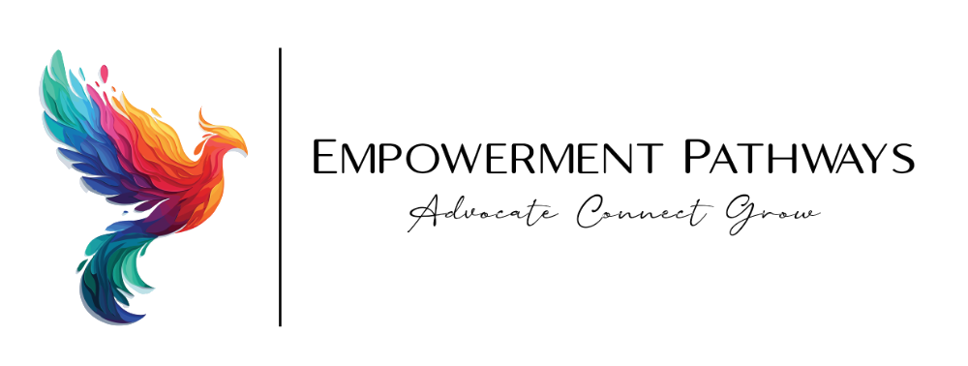
Executive Summary & Impact Report
June 2026
A nonprofit advocating for women, children, and families
OUR MISSION
Empowerment Pathways exists to advocate for women, children, and families by delivering parenting education, mental health therapy, and youth mentorship. Through compassionate care and steadfast advocacy, we help our community advocate, connect, and grow.

2025–2026 AT A GLANCE
164  Clients Served | 2,273  Appointments | 95%  Positive Outcomes

Community Growth
Over the past year, Empowerment Pathways has put down deep roots in the Wilson community, expanding both the number of families we serve and the strength of our local partnerships. What began as a small grassroots effort has grown into a trusted neighborhood resource for parents, youth, and caregivers.
Central to this momentum is our growing connection with Wilson Area LINCS (Linking Individuals, Neighborhoods, and Community Services). Through this partnership we coordinate referrals, share resources, and reach families who might otherwise fall through the cracks — ensuring that support is woven directly into the fabric of the Wilson community.
- Deeper engagement with families across the Wilson community.
- Active collaboration and referral pathways with Wilson Area LINCS.
- A growing network of community partners, schools, and local advocates.
Leadership
Empowerment Pathways has matured from a founding team of just 2 board members into a comprehensive leadership structure spanning executive, advisory, board, and director roles. This evolution gives the organization the governance depth and operational capacity to serve more families with accountability and care.
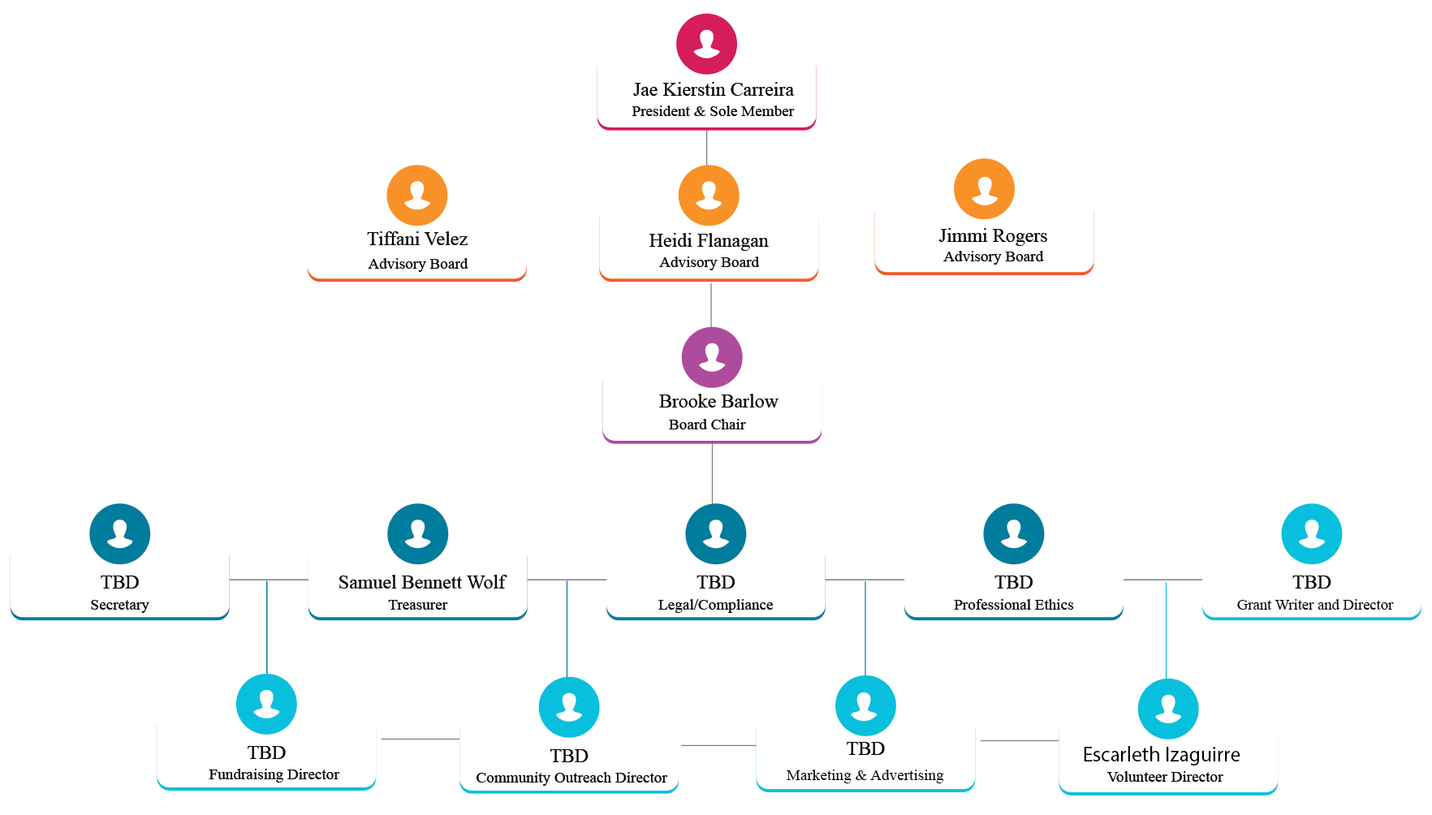
Our current organizational and leadership structure.
Clinical Expansion
Demand for mental health services has grown rapidly. In January 2025, Empowerment Pathways began with a single clinician. Today, our clinical team has grown fourfold to 4 clinicians, dramatically increasing our capacity to deliver timely therapy and support to women, children, and families.
1  Clinician  (January 2025) | → | 4  Clinicians  (Today)

University Internship Program
A cornerstone of our growth is our university internship program. Empowerment Pathways partners with leading local universities to welcome graduate-level interns into our clinical team, mentoring the next generation of mental health professionals while expanding the care we can offer.
We are proud to bring on interns from Marywood University and Moravian University. This partnership is more than training — it directly enables Empowerment Pathways to offer free therapy to community members who need it most, removing cost as a barrier to care.
Marywood University  Graduate clinical interns serving women, children, and families. | Moravian University  Emerging clinicians extending free, accessible therapy.

- Partnerships with Marywood University and Moravian University.
- Supervised graduate interns expand our clinical capacity year over year.
- Free therapy made possible for community members facing financial barriers.
Pathways to Discovery
Pathways to Discovery is our flagship one-month summer program for youth, designed to spark curiosity, build confidence, and foster connection. Each of the four weeks centers on a different theme, giving participants a fresh way to explore the world and themselves.
WEEK 1  Art  Creative expression through painting, crafts, and design. | WEEK 2  Nature  Outdoor exploration, environmental learning, and stewardship. | WEEK 3  Sports  Teamwork, movement, and healthy active play. | WEEK 4  Literature  Reading, storytelling, and the power of voice.

Beyond the summer, we sustain connection year-round through our virtual support groups — accessible, online gatherings that give parents and caregivers across the community a consistent space to share, learn, and grow together.
Impact by the Numbers
Behind every number is a family supported, a child encouraged, or a parent given new tools to thrive. Our 2025–2026 results reflect both reach and quality of care.
164  Clients Served | 2,273  Appointments Delivered | 95%  Reported Positive Outcomes

Join us in advocating for women, children, and families.
www.newempwermentpathways.org

